TOP VT 6820 S and TOP VT 7620 S
New twin rotor rakes deliver top results

At Pöttinger, the focus during development is always on the quality of the forage, conservation of the soil, and the durability of the machine. The company is setting new standards in this areas with the launch of the new TOP VT 6820 S and TOP VT 7620 S twin rotor rakes with side swath placement. Despite their low power requirement, the new rakes are designed to rake large swaths and deliver the best results. The TOP VT 6820 S achieves a working width of 6.80 m, while on the TOP VT 7620 it's an impressive 7.60 m.

Efficient and neat raking work
The angled tines lift the crop slightly to ensure it is swept cleanly without dragging the forage across the ground. The standard five wheel chassis in combination with the rotor mounted in gimbals ensures precision guidance of the tines over bumpy ground. As an option, a MULTITAST jockey wheel can be added to detect bumps ahead of the tines and lift the rotor accordingly. The raking height can be conveniently adjusted electro-hydraulically from the tractor cab, or manually using a hand crank. Likewise, the optional MULTITAST jockey wheel is adjusted automatically with the rotor chassis. Optional suspension springs also make sure that the rotors run smoothly in the working position.

Versatility in action
Thanks to the dual swath function, night swaths can be formed and the machines can be used to rake hay and straw. This flexibility makes it possible to adapt to different harvesting conditions and always achieve the best results.

Convenient operation and high manoeuvrability
One double-acting connection to the tractor hydraulics with float setting is all that is needed for lifting the rotors. Both rotors are lifted and lowered one after the other via step sequence control. Thanks to the Basicline preselect system, the rotor units can also be lifted or lowered individually, which is particularly practical for leftover areas and raking along field boundaries.

The TOP rakes also impress with their excellent manoeuvrability: The steered chassis enables a turning angle of 80° so that the rake follows exactly in the tractor's tracks. With a ground clearance of 50 cm, there is no problem driving over swaths. For a comfortable and safe ride during transport, the swath curtain folds in automatically, and the transport height remains under 4.0 metres, all without having to leave the cab.

Pöttinger, the grassland specialist, attaches great importance to the best ground tracking and gentle forage handling. The new TOP VT 6820 S and TOP VT 7620 S rakes are the top choice for efficient and successful harvesting.

Photo preview:
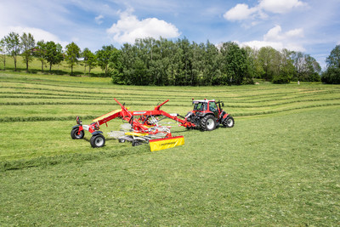 | 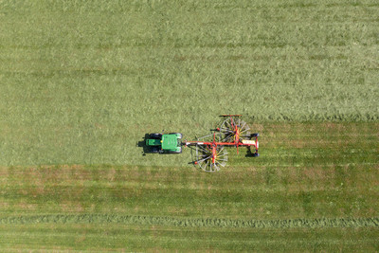
TOP VT 6820 S for neat raking work | TOP VT 7620 S for the best ground tracking and gentle forage handling
https://www.poettinger.at/de_at/newsroom/pressebild/135620 | https://www.poettinger.at/de_at/newsroom/pressebild/135619

More printer-optimised photos: www.poettinger.at/presse

